GALDERAK ETA ERANTZUNAK

USAINDU ADITZA



NOR? ZER? NON?

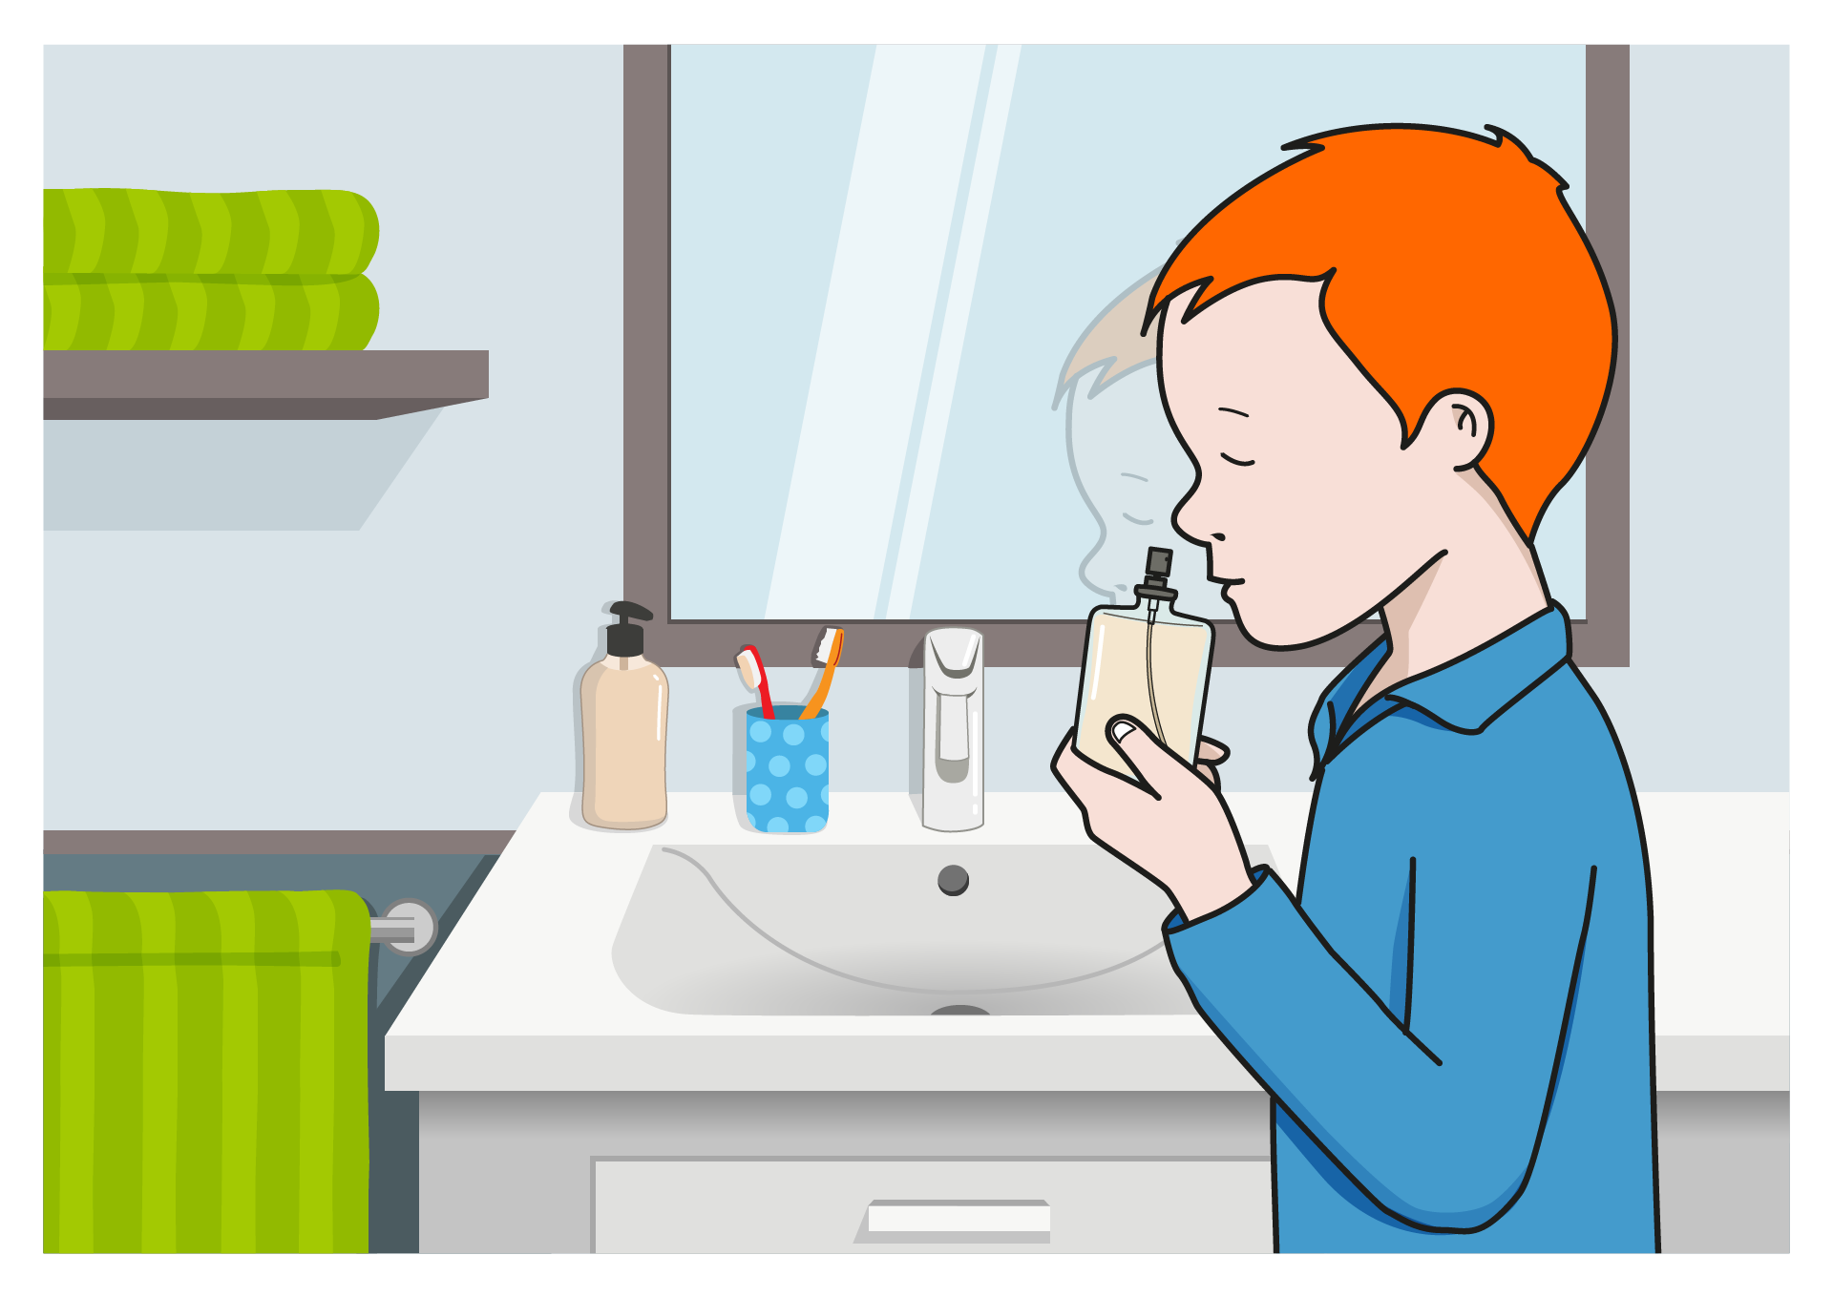

|  |  |  |  |
| --- | --- | --- | --- |
| **NOR DA?** | **AMONA** | **UMEA** | **ZALDIA** |
| **ZER EGITEN DU?** | **USAINDU** | **EDAN** | **JAN** |
| **ZER?** | **ZOPA** | **KOLONIA** | **LOREA** |
| **NON?** | **GAZTELUAN** | **PARKEAN** | **KOMUNEAN** |

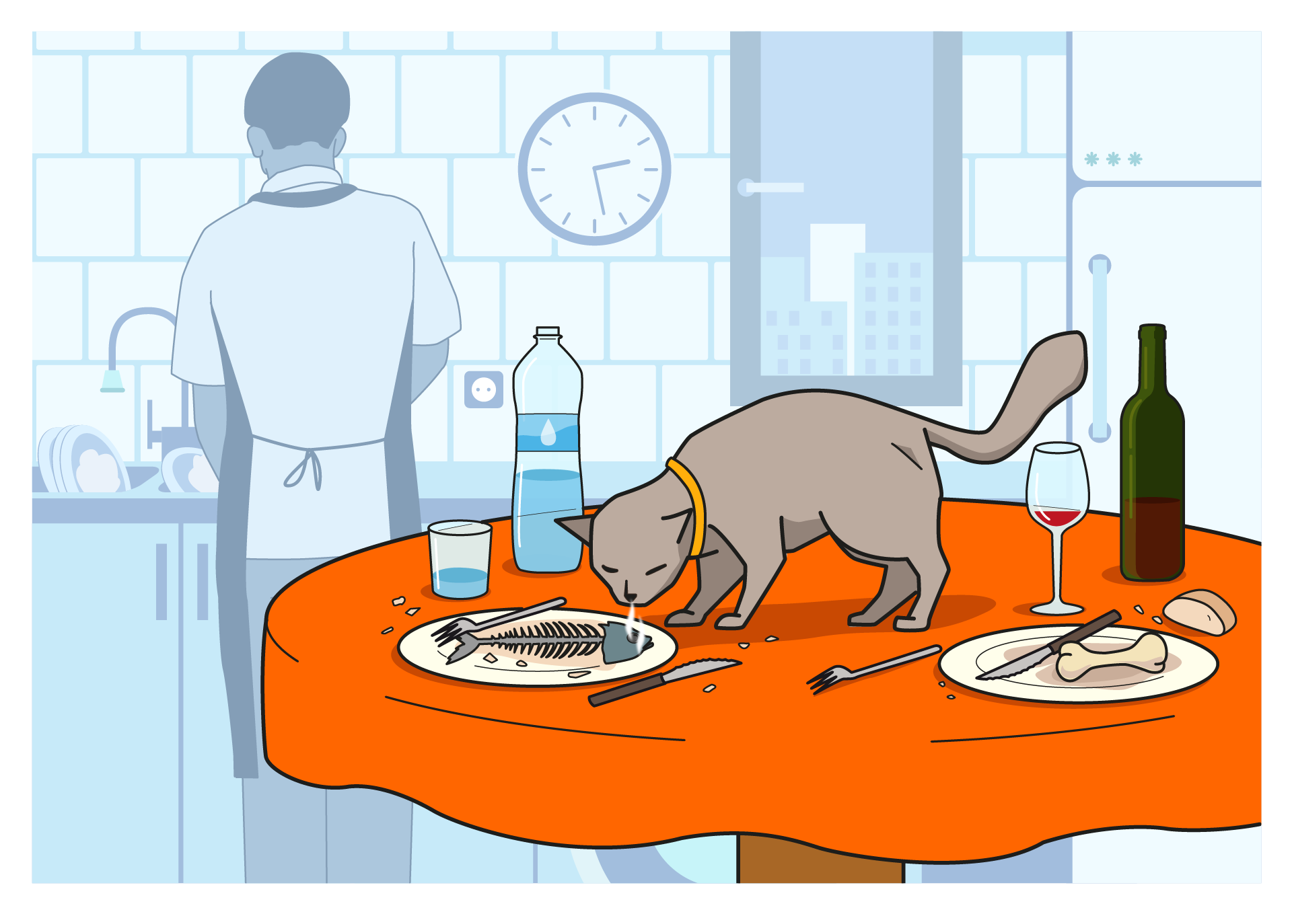

|  |  |  |  |
| --- | --- | --- | --- |
| **NOR DA?** | **KATUA** | **BEHIA** | **AITA** |
| **ZER EGITEN DU?** | **JAN** | **USAINDU** | **EDAN** |
| **ZER?** | **ARRAINA** | **XERRA** | **ARDOA** |
| **NON?** | **MENDIAN** | **SUKALDEAN** | **TABERNAN** |

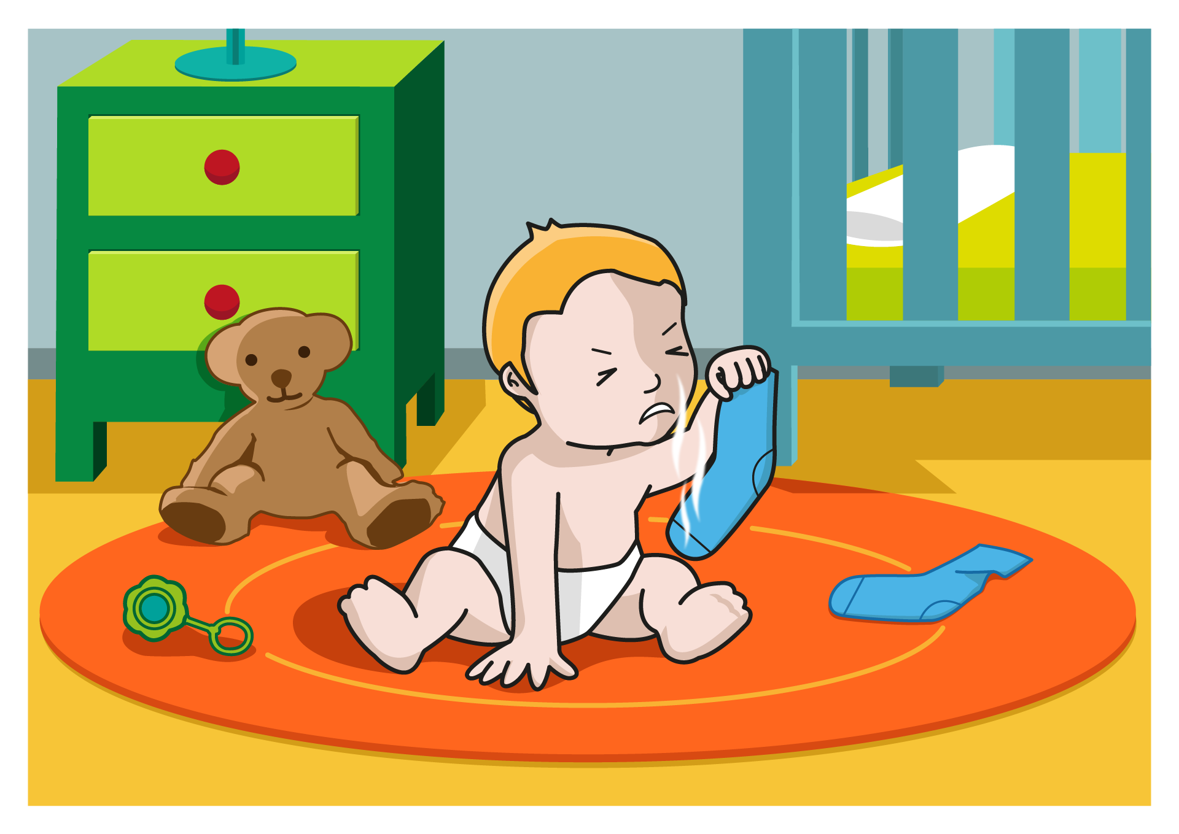

|  |  |  |  |
| --- | --- | --- | --- |
| **NOR DA?** | **TXAKURRA** | **NESKA** | **HAURTXOA** |
| **ZER EGITEN DU?** | **EDAN** | **JAN** | **USAINDU** |
| **ZER?** | **GALTZERDIA** | **PILOTA** | **ESKULARRUA** |
| **NON?** | **DENDAN** | **IGERILEKUAN** | **LOGELAN** |



|  |  |  |  |
| --- | --- | --- | --- |
| **NOR DA?** | **AMA** | **TXERRIA** | **AITA** |
| **ZER EGITEN DU?** | **USAINDU** | **EDAN** | **JAN** |
| **ZER?** | **LARANJA** | **LOREA** | **TARTA** |
| **NON?** | **EGONGELAN** | **ESKOLAN** | **ZELAIAN** |