GALDERAK ETA ERANTZUNAK

BEGIRATU ADITZA

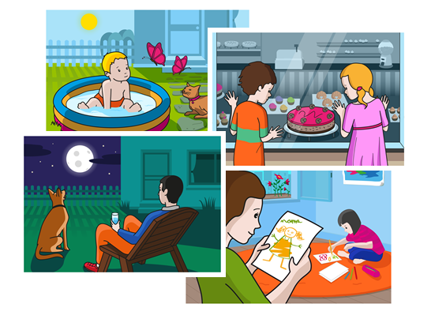

NORK? ZER? NON?

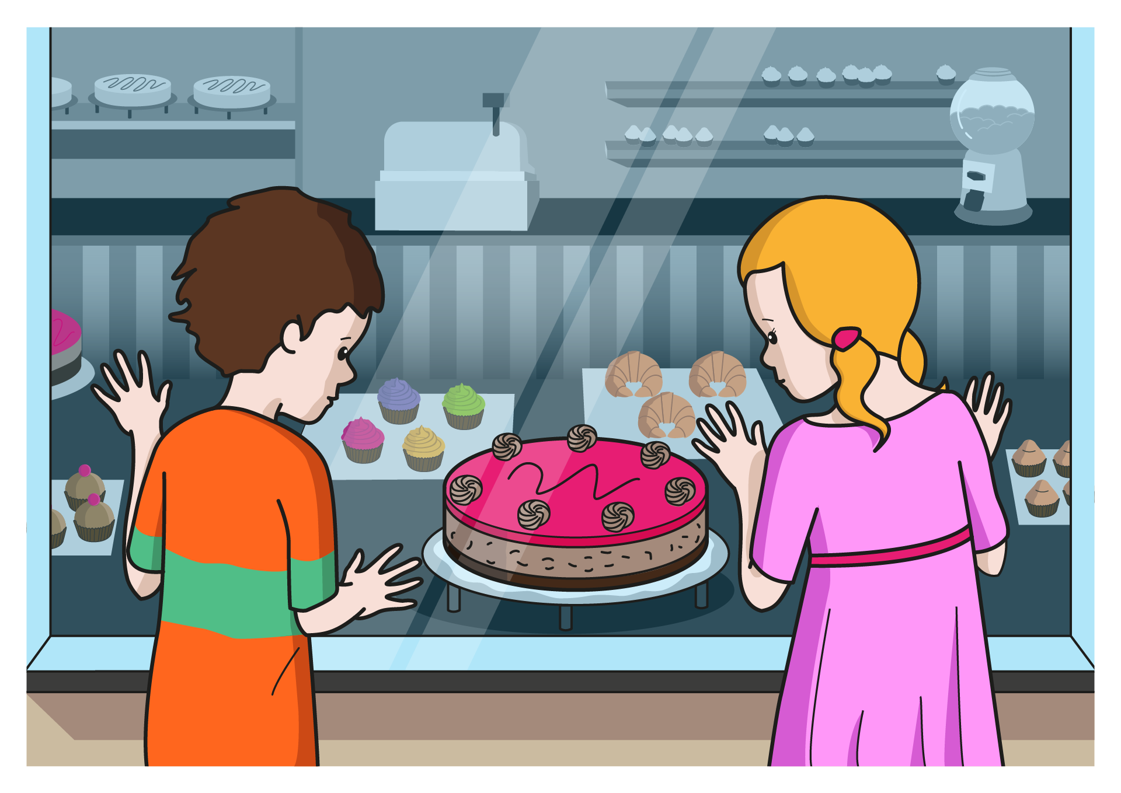

|  |  |  |  |
| --- | --- | --- | --- |
| **NOR DA?** | **MUTILA** | **AMONA** | **NESKA** |
| **ZER EGITEN DU?** | **EDAN** | **BEGIRATU** | **JAN** |
| **ZER?** | **HARTZATXOA** | **KOTXEA** | **TARTA** |
| **NON?** | **GOZOTEGIAN** | **PARKEAN** | **ZINEMAN** |

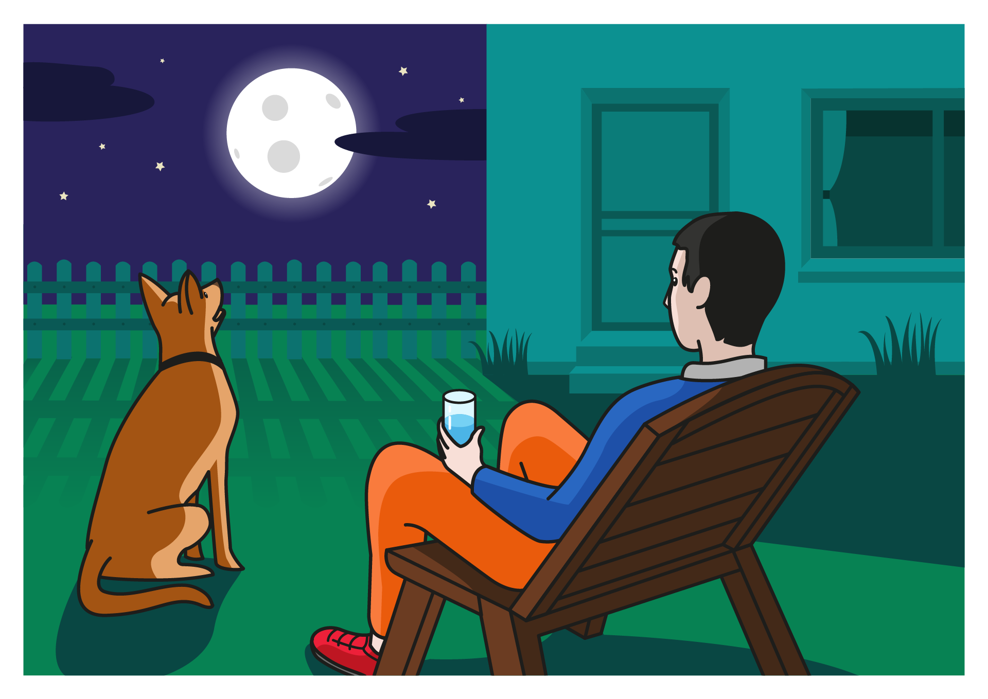

|  |  |  |  |
| --- | --- | --- | --- |
| **NOR DA?** | **KATUA** | **TXAKURRA** | **AITA** |
| **ZER EGITEN DU?** | **BEGIRATU** | **USAINDU** | **EDAN** |
| **ZER?** | **HEGAZKINA** | **ILARGIA** | **HODEIA** |
| **NON?** | **MENDIAN** | **ZERUAN** | **HONDARTZAN** |



|  |  |  |  |
| --- | --- | --- | --- |
| **NOR DA?** | **HAURTXOA** | **AITONA** | **KATUA** |
| **ZER EGITEN DU?** | **EDAN** | **BEGIRATU** | **JAN** |
| **ZER?** | **TXIMELETA** | **TXORIA** | **KOMETA** |
| **NON?** | **LORATEGIAN** | **ESKOLAN** | **LOGELAN** |

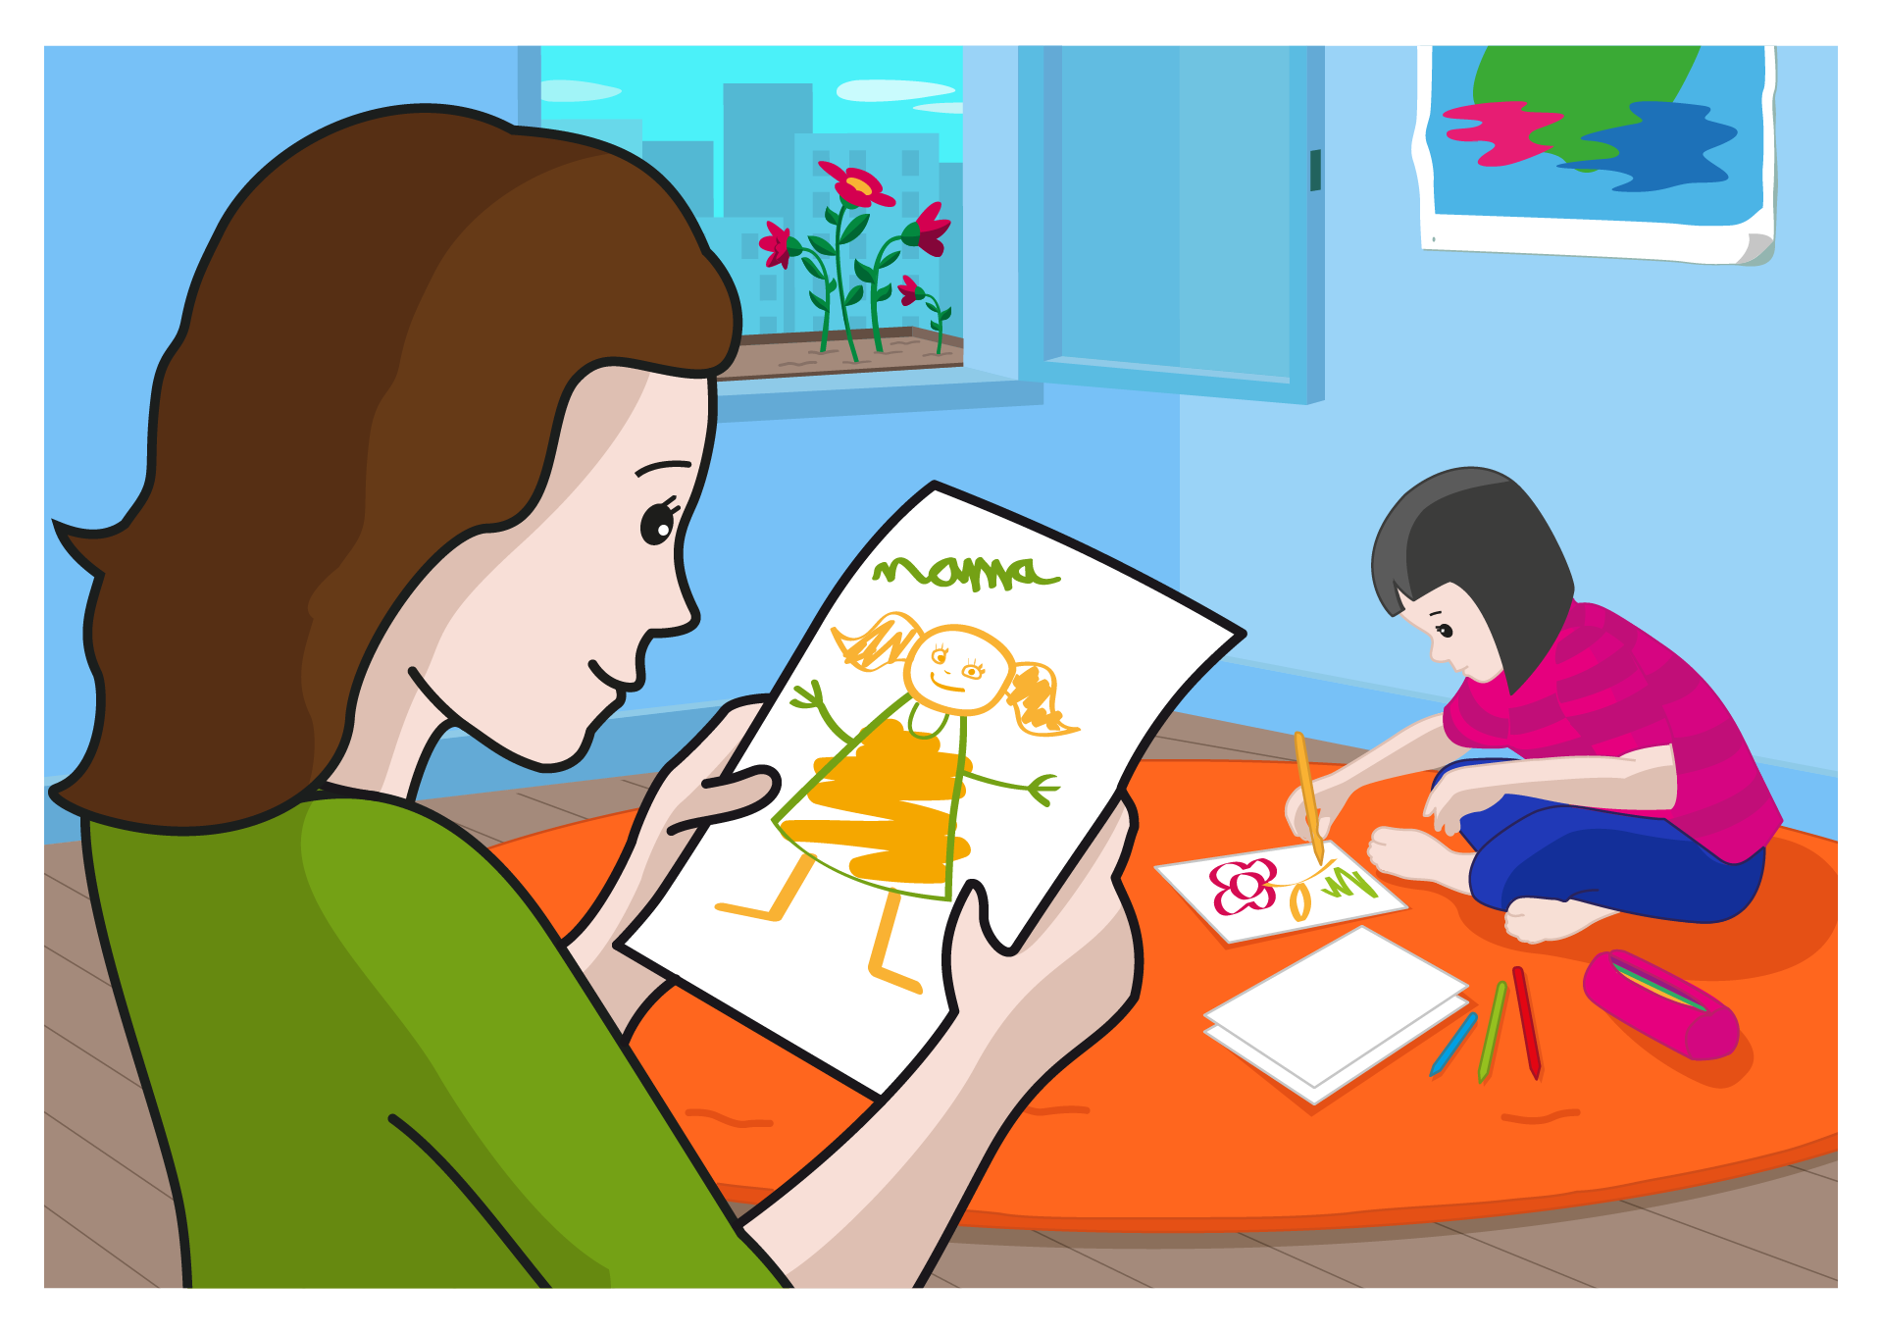

|  |  |  |  |
| --- | --- | --- | --- |
| **NOR DA?** | **MUTILA** | **AITA** | **AMA** |
| **ZER EGITEN DU?** | **USAINDU** | **EDAN** | **BEGIRATU** |
| **ZER?** | **TELEBISTA** | **PANPINA** | **MARRAZKIA** |
| **NON?** | **PARKEAN** | **EGONGELAN** | **ZELAIAN** |