|  |
| --- |
|  |

|  |
| --- |
|  |
| **Empareja** |
| **http://www.arasaac.org/classes/img/thumbnail.php?i=c2l6ZT0zMDAmcnV0YT0uLi8uLi9yZXBvc2l0b3Jpby9vcmlnaW5hbGVzLzExNjk0LnBuZw==http://www.arasaac.org/classes/img/thumbnail.php?i=c2l6ZT0zMDAmcnV0YT0uLi8uLi9yZXBvc2l0b3Jpby9vcmlnaW5hbGVzLzE1MDE4LnBuZw==[Fotografías-Pictogramas]** |

Autora: Jennifer de Sandoval Rodríguez. SINPROMI.S.L.

Este material se elabora con el objetivo de disponer de recursos para el entrenamiento de la fase de transición de fotos reales a pictogramas; está basado en el material elaborado por Rosa Asín y Ana Isabel Álava (Empareja: *Autor pictogramas: Sergio Palao Procedencia: ARASAAC (http:// arasaac.org) Licencia: CC (BY-NC-SA) http://logopediaenespecial.blogspot.com.es/ Autoras: Rosa Asín y Ana Isabel Alava))*

En la propuesta se incluyen láminas con unas imágenes reales y unas fichas de pictogramas, incluidos en el anexo.

¿Cómo se realiza la actividad?

Te facilitamos el material para que puedas imprimirlo y modificarlo. Recuerda que en el apartado de anexo debes recortar los pictogramas para poder usarlo en las fichas propuestas.

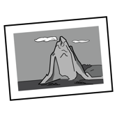Empareja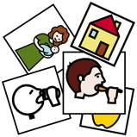

|  |  |  |  |
| --- | --- | --- | --- |
| Padre |  | Abuelo |  |
| Hombre |  | Niño |  |

Empareja

|  |  |  |  |
| --- | --- | --- | --- |
| Duchar |  | Vestir |  |
| Secar el pelo |  | Cepillar los dientes |  |

Empareja

|  |  |  |  |
| --- | --- | --- | --- |
| Anillo |  | Pulsera |  |
| Reloj |  | Pendientes |  |

Empareja

|  |  |  |  |
| --- | --- | --- | --- |
| Lápices |  | Bolígrafo |  |
| Borrador |  | Libro |  |

Empareja

|  |  |  |  |
| --- | --- | --- | --- |
| Comer |  | Beber |  |
| Dormir |  | Coger |  |

Empareja

|  |  |  |  |
| --- | --- | --- | --- |
| Pan |  | Huevos duros |  |
| Lechuga |  | Cocinar |  |

Empareja

|  |  |  |  |
| --- | --- | --- | --- |
| Pie |  | Boca |  |
| Mano |  | Oreja |  |

Empareja

|  |  |  |  |
| --- | --- | --- | --- |
| Sopa |  | Agua |  |
| Tenedor |  | Plato |  |

Empareja

|  |  |  |  |
| --- | --- | --- | --- |
| Fregona |  | Cepillo de barrer |  |
| Regadera |  | Estropajo |  |

Empareja

|  |  |  |  |
| --- | --- | --- | --- |
| Mirar |  | Oler |  |
| Escuchar música |  | Hablar |  |

Empareja

|  |  |  |  |
| --- | --- | --- | --- |
| Playa |  | Montaña |  |
| Calle |  | Piscina |  |

Empareja

|  |  |  |  |
| --- | --- | --- | --- |
| Peine y tijeras |  | Enchufe |  |
| Grifo |  | Fonendoscopio |  |

Empareja

|  |  |  |  |
| --- | --- | --- | --- |
| Enfermo |  | Cortar |  |
| Ir |  | Volver |  |

Empareja

|  |  |  |  |
| --- | --- | --- | --- |
| Abrir |  | Cerrar |  |
| Hola |  | Adiós |  |

Empareja

|  |  |  |  |
| --- | --- | --- | --- |
| Váter |  | Cama |  |
| Sartén |  | Sofá |  |

**Anexo**

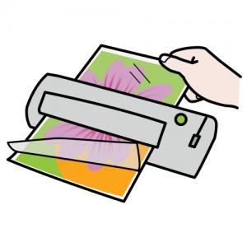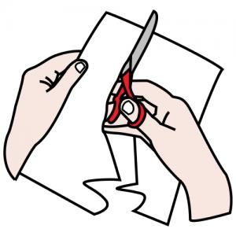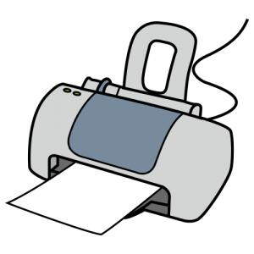

Pictogramas imprimir, recortar y plastificar.

|  |  |  |  |
| --- | --- | --- | --- |
| _copytoWordPicto_ | _copytoWordPicto_ | _copytoWordPicto_ | _copytoWordPicto_ |
| _copytoWordPicto_ | _copytoWordPicto_ | _copytoWordPicto_ | _copytoWordPicto_ |

http://www.arasaac.org/classes/img/thumbnail.php?i=c2l6ZT0zMDAmcnV0YT0uLi8uLi9yZXBvc2l0b3Jpby9vcmlnaW5hbGVzLzI1OTEucG5n

|  |  |  |  |
| --- | --- | --- | --- |
| _copytoWordPicto_ | _copytoWordPicto_ | _copytoWordPicto_ | _copytoWordPicto_ |
| _copytoWordPicto_ | _copytoWordPicto_ | _copytoWordPicto_ | _copytoWordPicto_ |

|  |  |  |  |
| --- | --- | --- | --- |
| http://www.arasaac.org/classes/img/thumbnail.php?i=c2l6ZT0zMDAmcnV0YT0uLi8uLi9yZXBvc2l0b3Jpby9vcmlnaW5hbGVzLzI1OTEucG5n_copytoWordPicto_ | _copytoWordPicto_ | _copytoWordPicto_ | _copytoWordPicto_ |
| _copytoWordPicto_ | _copytoWordPicto_ | _copytoWordPicto_ | _copytoWordPicto_ |

|  |  |  |  |
| --- | --- | --- | --- |
| _copytoWordPicto_ | _copytoWordPicto_ | _copytoWordPicto_ | _copytoWordPicto_ |
| _copytoWordPicto_ | _copytoWordPicto_ | _copytoWordPicto_ | _copytoWordPicto_ |

http://www.arasaac.org/classes/img/thumbnail.php?i=c2l6ZT0zMDAmcnV0YT0uLi8uLi9yZXBvc2l0b3Jpby9vcmlnaW5hbGVzLzI1OTEucG5n

|  |  |  |  |
| --- | --- | --- | --- |
| _copytoWordPicto_ | _copytoWordPicto_ | _copytoWordPicto_ | _copytoWordPicto_ |
| _copytoWordPicto_ | _copytoWordPicto_ | _copytoWordPicto_ | _copytoWordPicto_ |

http://www.arasaac.org/classes/img/thumbnail.php?i=c2l6ZT0zMDAmcnV0YT0uLi8uLi9yZXBvc2l0b3Jpby9vcmlnaW5hbGVzLzI1OTEucG5n

|  |  |  |  |
| --- | --- | --- | --- |
| _copytoWordPicto_ | _copytoWordPicto_ | _copytoWordPicto_ | _copytoWordPicto_ |
| _copytoWordPicto_ | _copytoWordPicto_ | _copytoWordPicto_ | _copytoWordPicto_ |

http://www.arasaac.org/classes/img/thumbnail.php?i=c2l6ZT0zMDAmcnV0YT0uLi8uLi9yZXBvc2l0b3Jpby9vcmlnaW5hbGVzLzI1OTEucG5n

|  |  |  |  |
| --- | --- | --- | --- |
| _copytoWordPicto_ | _copytoWordPicto_ | _copytoWordPicto_ | _copytoWordPicto_ |
| _copytoWordPicto_ | _copytoWordPicto_ | _copytoWordPicto_ | _copytoWordPicto_ |

http://www.arasaac.org/classes/img/thumbnail.php?i=c2l6ZT0zMDAmcnV0YT0uLi8uLi9yZXBvc2l0b3Jpby9vcmlnaW5hbGVzLzI1OTEucG5n

|  |  |
| --- | --- |
| _copytoWordPicto_ | _copytoWordPicto_ |
| _copytoWordPicto_ | _copytoWordPicto_ |

**http://www.arasaac.org/classes/img/thumbnail.php?i=c2l6ZT0zMDAmcnV0YT0uLi8uLi9yZXBvc2l0b3Jpby9vcmlnaW5hbGVzLzI1OTEucG5n**